Flight Price Prediction

Problem Definition:-

Flight ticket prices can be something hard to guess, today we might see a price, check out the price of the same flight tomorrow, it will be a different story. We might have often heard travellers saying that flight ticket prices are so unpredictable. Here you will be provided with prices of flight tickets for various airlines between the months of March and June of 2019 and between various cities.
Size of training set: 10683 records
Size of test set: 2671 records

FEATURES:
Airline: The name of the airline.
Date_of_Journey: The date of the journey
Source: The source from which the service begins.
Destination: The destination where the service ends.
Route: The route taken by the flight to reach the destination.
Dep_Time: The time when the journey starts from the source.
Arrival_Time: Time of arrival at the destination.
Duration: Total duration of the flight.
Total_Stops: Total stops between the source and destination.
Additional_Info: Additional information about the flight
Price: The price of the ticket

Data Analysis:-

The very first step to begin with is to import the provided data set and required libraries for data analysis.

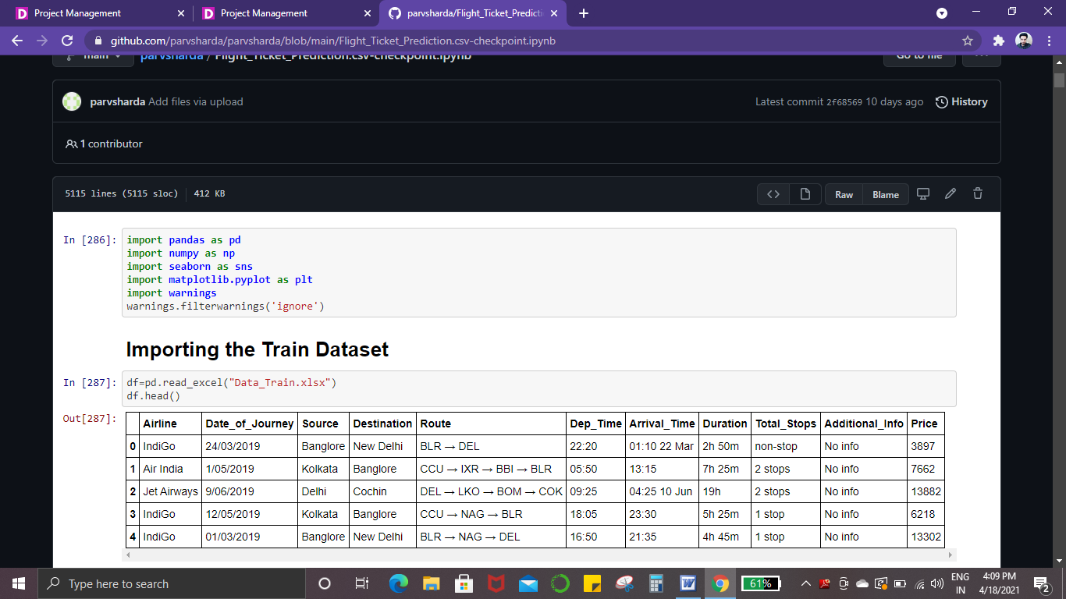

Below codes shows us the name of each feature in the data set, data types of our dataset plus we can also see that our dataset has 10683 rows and 11 features/columns

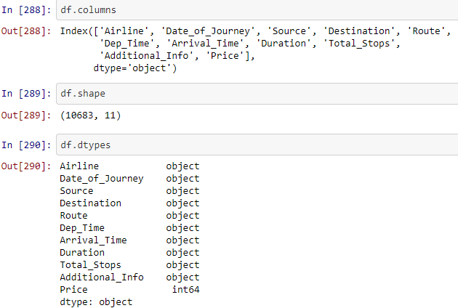

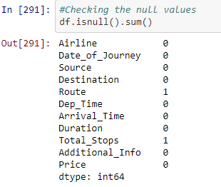

Checking missing values in the dataset is also one the most important task, we can see in the above picture that we have some missing data.

Now we already know that we have a large dataset available with us hence we can simply drop the missing set as there will be almost no impact on our dataset.

We can see the impact on our dataset after dropping null values using below code:-

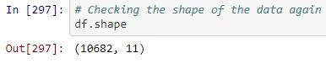
We have lost only 1 row after dropping the null values.

Date_of_Journey column is a object datatype, hence we will convert this datatype into timestamp.

We will be using pandas to_dateetime function to convert this object to datetime dtype.

.dt.day method will extract the day of that date .dt.month method will extract the month of the date
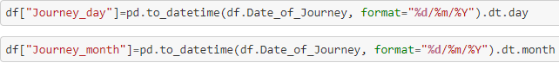
We have already extracted day and month from the Date_of_Journey column, hence we will be removing the Date_of_Journey column.
We can use the same method to extract hour and minute from Dep_Time and Arrival_Time column and once the extraction is done we will be removing the Dep_Time column.
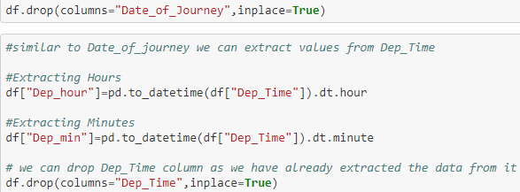

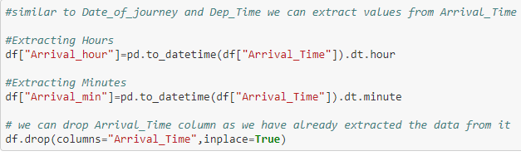

Time taken by plane to reach destination is called Duration
It is the difference between Departure Time and Arrival time

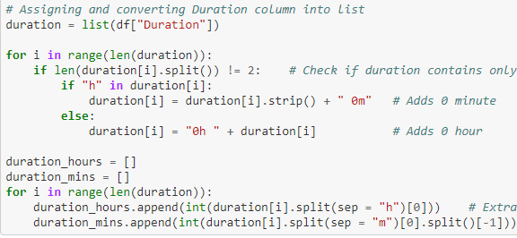

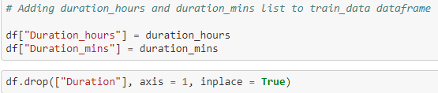

EDA Remarks

During EDA, we found that there are null values so we dropped the null values.

Also features like ‘Date_of_journey’,’Dep_Time’,’Arrival_Time’ and ‘Duration’were in a different format, we extracted the required data from them and then dropped these columns.

We have new columns in our data set after extraction of data such as:-

- Journey_day
- Journey_month
- Dep_hour
- Dep_min
- Arrival_hour
- Arrival_min
- duration_hour
- duration_mins

Pre-Processing Pipeline

In the pre-processing pipeline our first task will be to handle the categorical data.

One can find many ways to handle categorical data. Some of them categorical data are,

Nominal data --> data are not in any order --> OneHotEncoder is used in this case Ordinal data --> data are in order --> LabelEncoder is used in this case

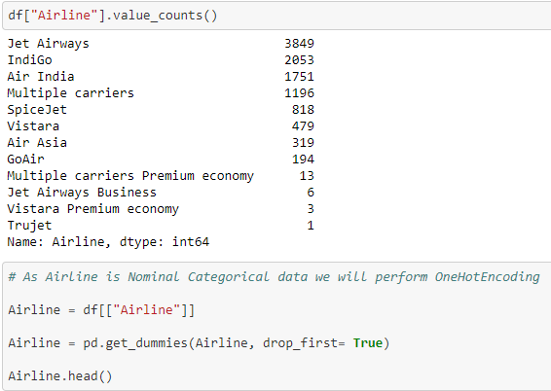

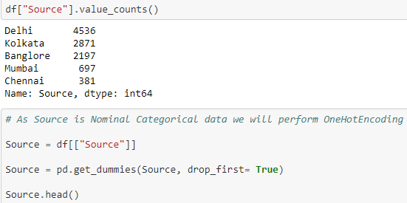

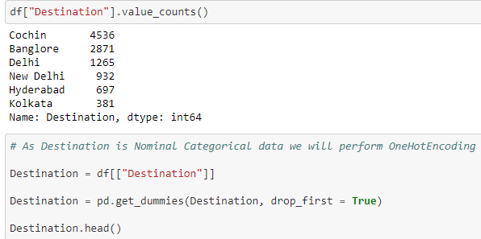

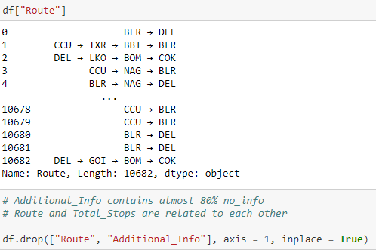

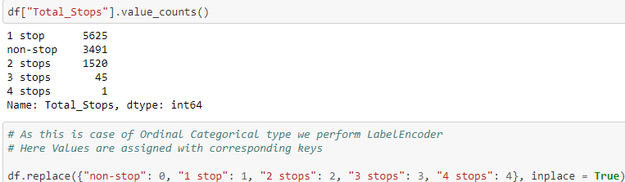

We have handled all the categorical data using Label Encoding and One Hot Encoding

Now after using pd.get_dummies function we have now columns available with us, hence now we can to concatenating the new features in a new variable Data_train

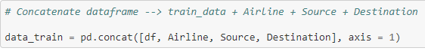

Now we will be dropping columns such as ‘Airline’,’Source’,’Destination’ as we have already handled the categorical data using One hot coding and Label Encoding.

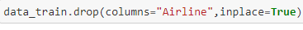
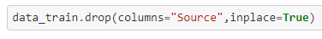
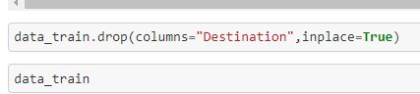

Now we have been provided with a Test set as well, hence we will also follow the same EDA and pre-processing pipeline as the Train set

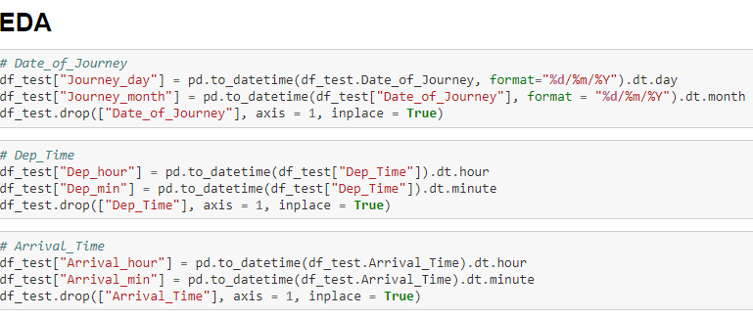

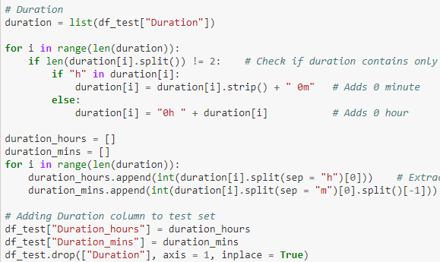

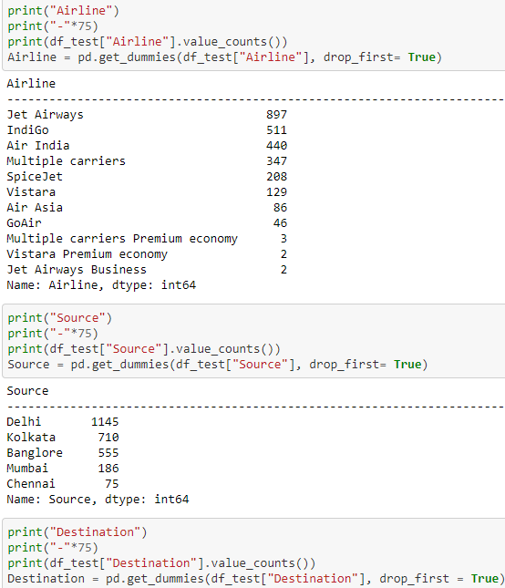

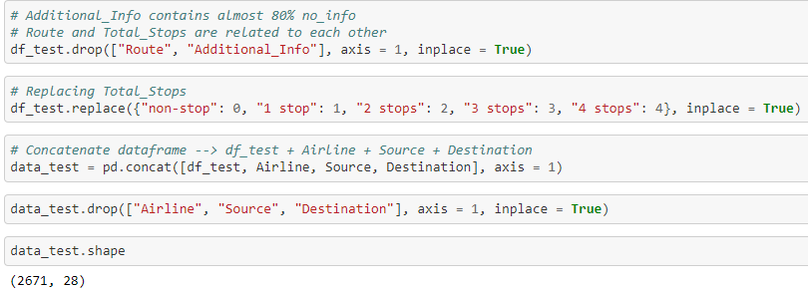

Now we can split our dataset in x and y:-

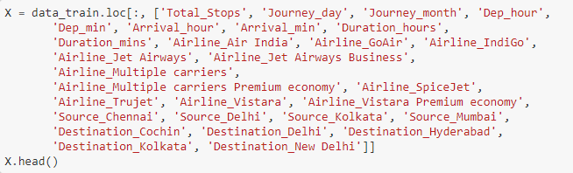

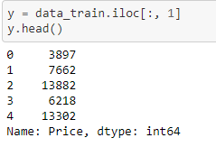

We can check the correlation matrix as well using below code:-
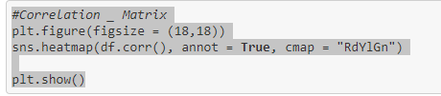

We have tried a number of models however we get the best accuracy from RandomForest Regressor

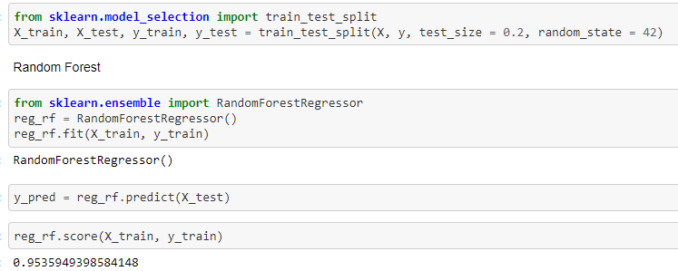

We can save the model using pickle

